Name: Mallela Kranthikumar
Batch: June 01 2022
Tutor: Raham Shaik
Project Name: Artifactory and Code.

NEXUS ARTIFACTORY ON UBUNTU:
- As a Prerequisite installed the vim package and java package
- Went to the cd/opt directory and Fetched the Nexus download link https://download.sonatype.com/nexus/3/nexus-3.39.0-01-unix.tar.gz from the internet.
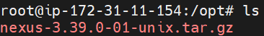
- Untar the nexus-3.39.0-01-unix.tar.gz file by running the ( tar -zxvf nexus-3.39.0-01-unix.tar.gz ) command
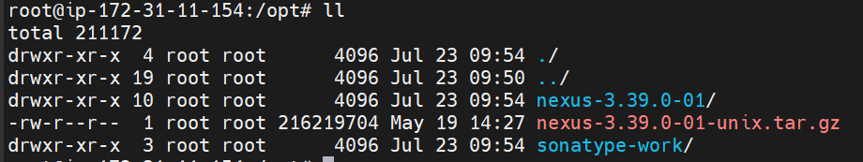
- Rename the nexus-3.39.0-01 to nexus by running the ( mv /opt/nexus-3.39.0-01 /opt/nexus ) command.
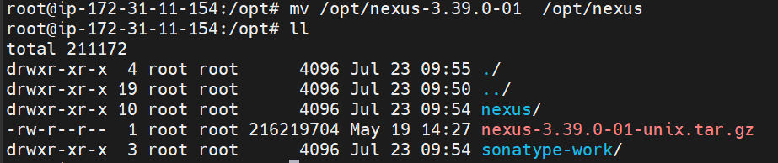
- Added nexus user by running the ( useradd nexus ) command.
- Given Root Privileges to nexus user by running the ( visudo ) command.
- Changed the ownership of the nexus by running the (chown -R nexus:nexus /opt/nexus and chown -R nexus:nexus /opt/sonatype-work ) commands.
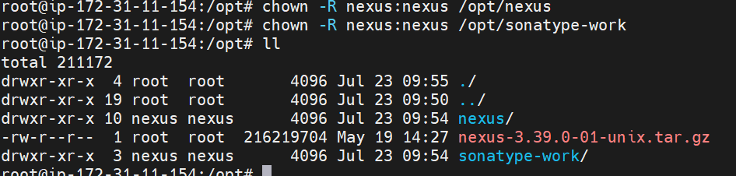
- Ran the vim /opt/nexus/bin/nexus.rc and nexus to run as a user.
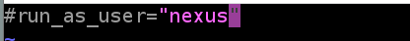
- To check the memory allocation ran the ( vim /opt/nexus/bin/nexus.vmoptions ) command and checked the memory allocation.
- Wrote the simple script to launch the nexus repos by running the ( vim /etc/system/system/nexus.service ) command.
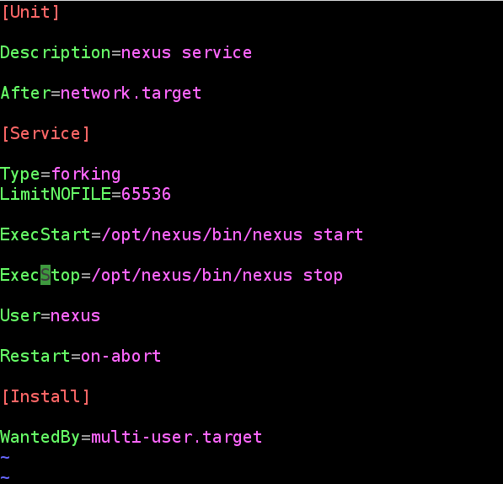
- Started the nexus services by running the ( systemctl start nexus ) command.
- Enabled the nexus service by running the ( systemctl enable nexus ) command.
- Checked the nexus service status by running the ( systemctl status nexus ) command.

- Taken the Public IP address and log into the web console with port 8081.
- Successfully launched the nexus artifact.
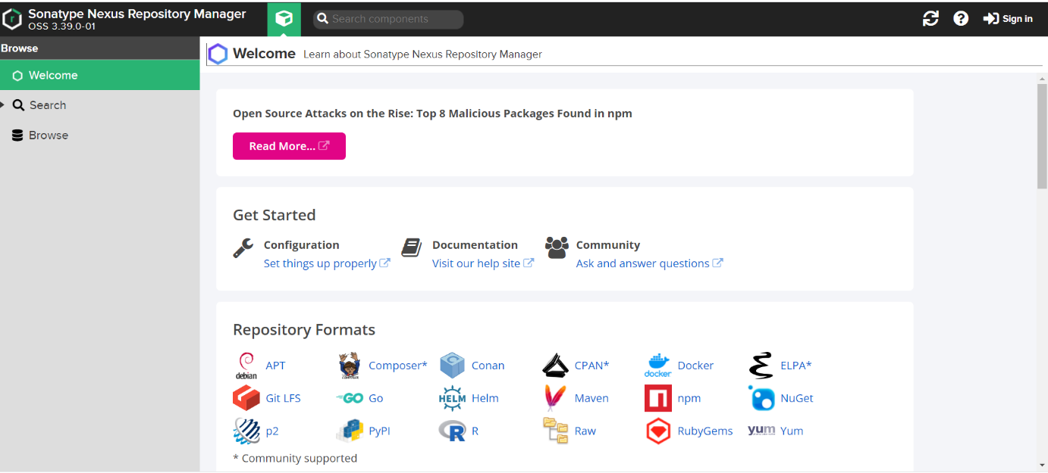
- Default admin user password is located in /opt/sonatype-work/nexus3/admin.password on the server.
]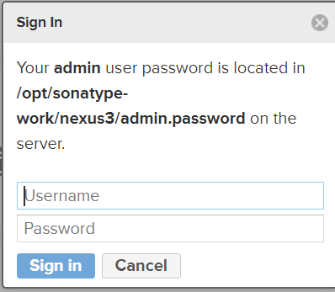
- Accessed the Password by running the ( cat /opt/sonatype-work/nexus3/admin.password ) command.

- To log in used admin as the username and password as the default password.
- Changed the password immediately once login with the default password and enabled a few steps.

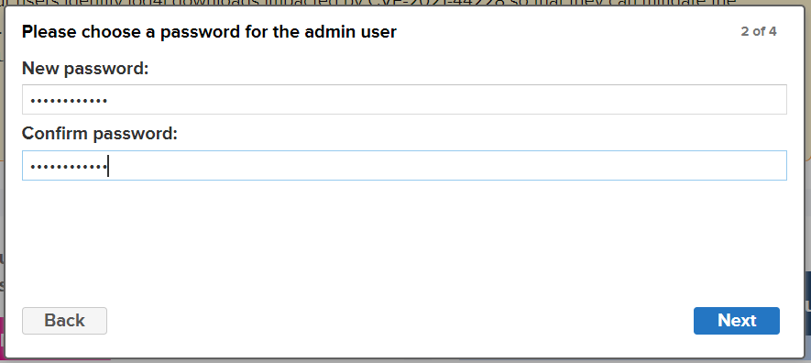

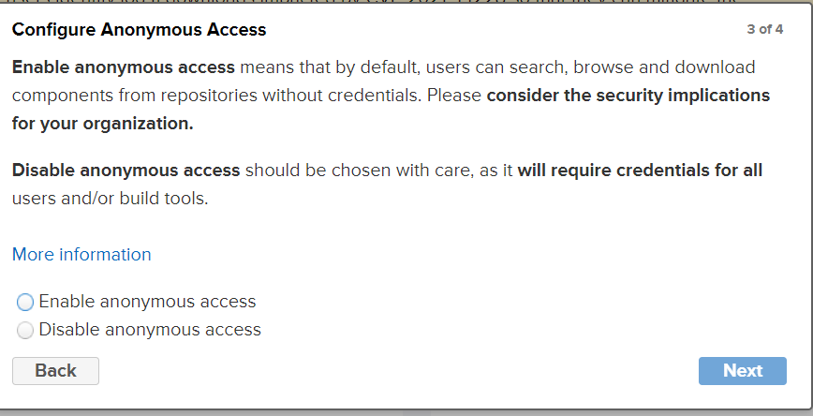
- Successfully logged in to nexus artifact and was able to access it.

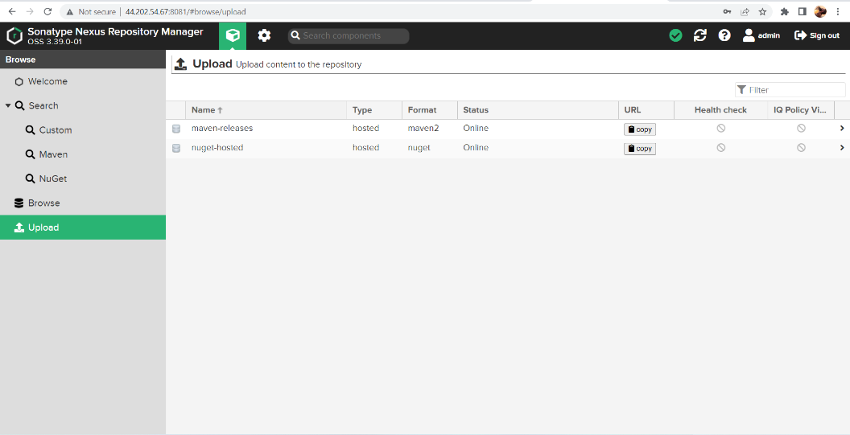

SONARQUBE INSTALLATION ON AMAZON LINUX:

- Installed Java 11 by running the ( amazon-linux-extras install java-openjdk11 ) command.
- Fetched the sonarqube setup file from the internet by using the wget https://binaries.sonarsource.com/Distribution/sonarqube/sonarqube-9.4.0.54424.zip
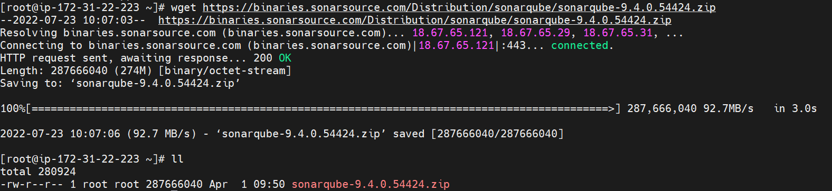
- Moved to /opt directory and unzipped by running command unzip the sonarqube-9.4.0.54424. directory

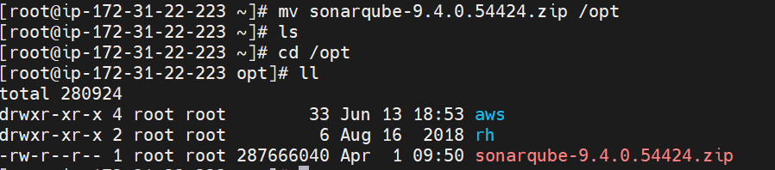
- Added sonaradmin user
- Changed the ownership of the file to sonaradmin by running the ( chown -R sonaradmin:sonaradmin sonarqube-9.4.0.54424 ) command.
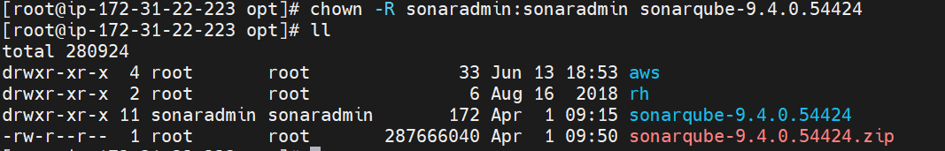
- Switched to sonaradmin to start the sonar services
- Moved to /opt/sonarqube-9.4.0.54424/bin/linux-x86-64 directory.
- Started the sonar.sh services by running ( ./sonar.sh start ) command.

- Checked the status of the sonarqube services by running the ( ./sonar.sh status ) command.
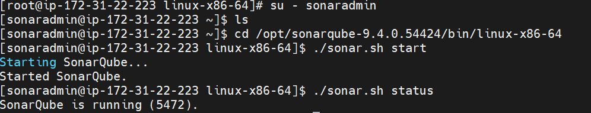
- Taken the instance Public IP address: 18.215.148.126 and used port 9000 to access the SonarQube web interface.
- Successfully launched the sonarqube.
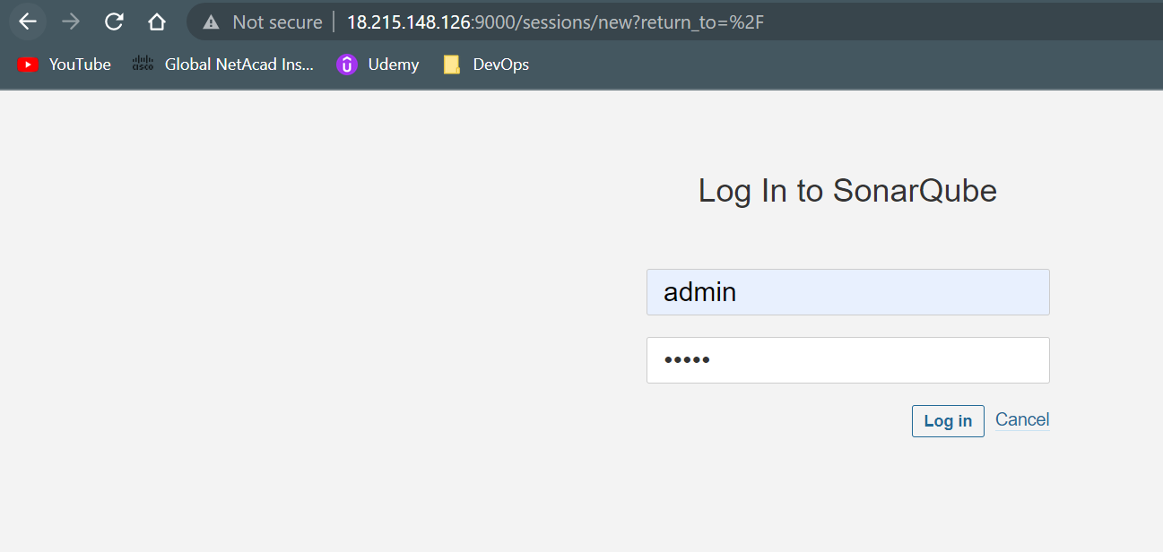
- Logged with admin user name and password admin.
- Changed the Password.
- Successfully accessed SonarQube Web interface.
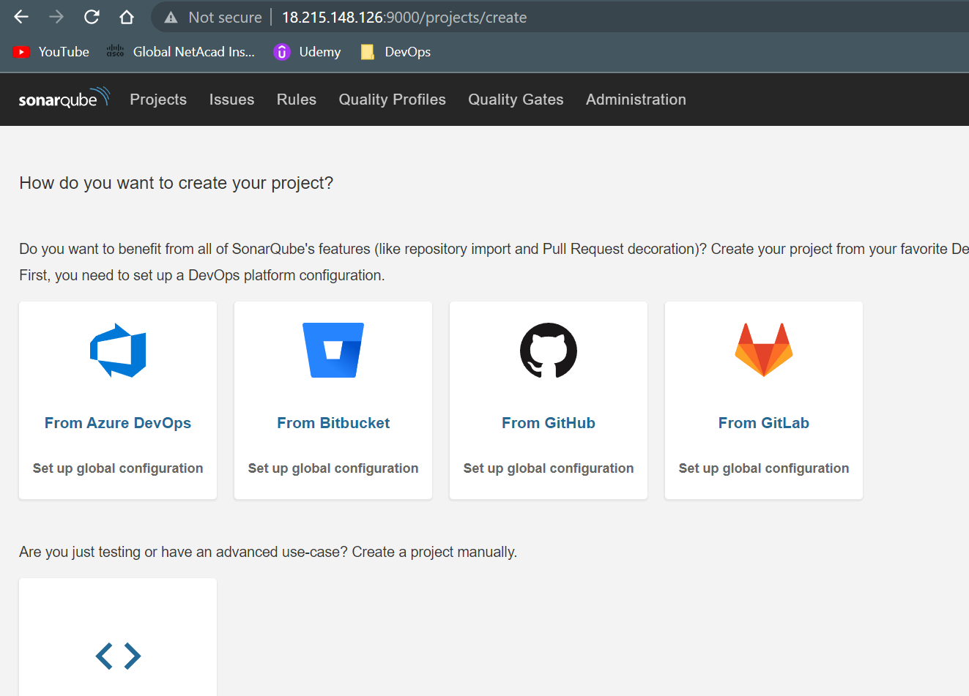

JFROG INSTALLATION ON AMAZON INSTANCE:

Artifactory Pro Install in Linux
- Connected to instance and switched to root user
- Performed below commands:
$ cd /opt/
$ wget https://releases.jfrog.io/artifactory/artifactory-pro/org/artifactory/pro/jfrog-artifactory-pro/7.23.3/jfrog-artifactory-pro-7.23.3-linux.tar.gz
$ tar -zxvf jfrog-artifactory-pro-7.23.3-linux.tar.gz
$ cd artifactory-pro-7.23.3
$ cd app/bin
$ ./artifactory.sh start
$ ./artifactory.sh status
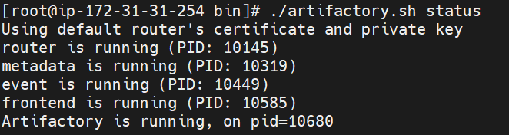
- Taken the Public IP address and accessed the JFROG with port number 8082.
- 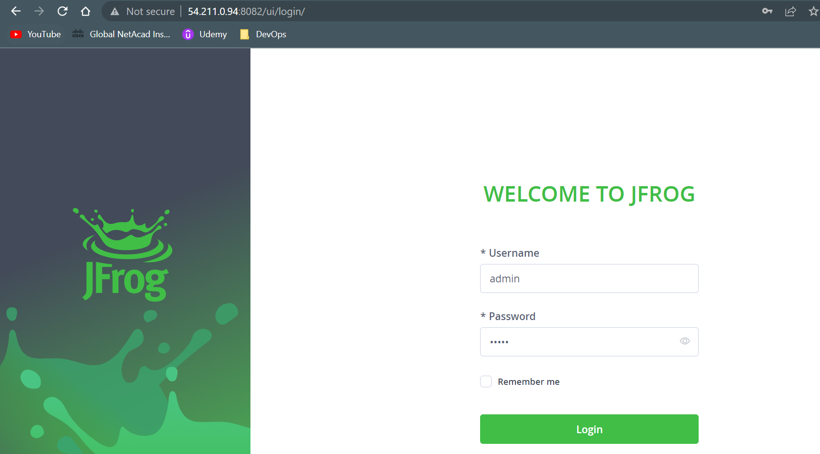
- Logged into JFROG with username= admin and Password: password. After Successfully logged in changed the password.

